
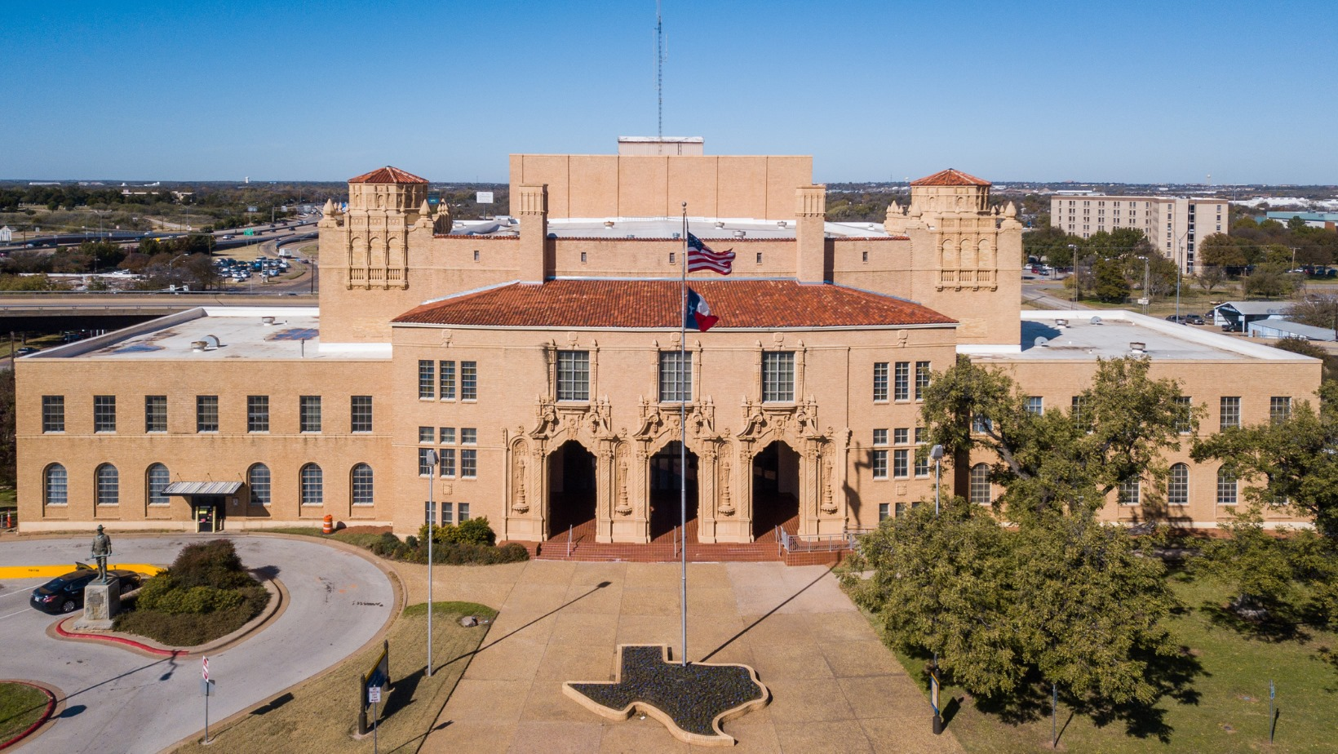
Completed Applications are due by April 4, 2025, at 5:00 PM.

Grant Funding

Application

PY / FY 2025-26 Community Development Block Grant (CDBG)
October 1, 2025 – September 30, 2026

City of Wichita Falls  Neighborhood Resources | 1800 7th Street, Wichita Falls, Texas 76301  940-761-7448

Community Development Block Grant Program
The City of Wichita Falls is an Entitlement Grantee for the U.S. Department of Housing and Urban Development’s Community Development Block Grant (CDBG) Program, which means the City receives a direct annual appropriation of funds from the Congressional budget process. These funds are used for projects and activities that help develop and maintain a desirable living environment for the citizens of Wichita Falls and are primarily used to benefit low to moderate-income areas and persons.

Local non-profit organizations are an important part of the program. Without this involvement, the CDBG Program could not address the broad range of needs in our community in a cost-effective way.

In keeping with the national objectives to develop a viable urban community, the City of Wichita Falls has adopted the following to be the major goals and objectives of the Community Development Block Grant program.

Application for Community Development Block Grant Funding does not guarantee funding. CDBG funding is competitive and based upon a project’s eligibility under the regulations and demonstrated need. The Wichita Falls City Council selects recipients and must consider all proposed CDBG projects in light of current community priorities and needs as identified in the Five-Year Consolidated Plan.

GOALS

- To promote the conservation and expansion of the city’s housing stock to help ensure the availability of decent, safe, and sanitary housing for all residents of Wichita Falls, especially those residents of low-to-moderate income.

- To stabilize, preserve, and improve established neighborhoods, particularly those identified as low-to-moderate income neighborhoods.

- To promote expanded economic opportunities that contribute to the improvement of a suitable living environment, especially for those residents of low and moderate-income.

OBJECTIVES

- To improve the existing housing stock by providing limited repair of owner-occupied homes of eligible low-to-moderate income residents.

- To provide improved basic urban amenities including paved streets, adequate water and sewer services, parks, and improvements to other public facilities within the CDBG-Eligible Target Areas.

- To eliminate neighborhood-degrading slum and blight conditions through services such as code enforcement and demolition of hazardous structures.

- To assist non-profit organizations in the provision of essential support services necessary to promote a suitable living environment for low-to-moderate income residents of Wichita Falls.

Responsibilities of CDBG Subrecipients

The Community Development Block Grant Program is a financial resource that enables the
City of Wichita Falls to undertake unique and varied activities. Non-profit agencies and organizations must carry out projects or activities with CDBG assistance that help achieve Community Development goals and objectives and meet basic eligibility criteria under the CDBG regulations.

The final responsibility for the Community Development Block Grant Program rests with the Wichita Falls City Council. The City must protect the investment of public money. To ensure approved activities and projects benefit the community, assist low-to-moderate income persons, and comply with federal regulations, certain responsibilities are required of recipients of CDBG assistance.

1. The recipient must agree to comply with all applicable federal, state, and local laws and regulations applicable to the project.

2. Recipients are required to enter into a contract as a subrecipient with the City of Wichita Falls that governs the organization’s responsibilities and obligations, performance and reporting requirements, and recordkeeping about financial standards and program beneficiaries.

3. In undertaking the project or activity, the recipient shall ensure that no person shall be denied benefits of the program or activity because of age, sex, race, religion, national origin, familial status, or handicapped status.

4. For projects that require the hiring of a contractor to complete the work, the organization must execute a written contract with the tradesman or company involved that specifies the work to be performed, the timeframe for completion, details the cost breakdown and contains language which requires the contractor to abide by federal Davis-Bacon wage regulations for any construction-related project in which the cost exceeds $2,000.

5. Upon completion of the project, the recipient organization must provide an accomplishment report that includes a brief narrative of how the project improved the organization or the people served, the number of unduplicated persons assisted by the organization’s program, their race and ethnicity, and with certain types of projects, the household income of the family.

*** NOTE ***

Following approval for funding, the recipient organization must not enter into any contract or begin work on their proposed project until a contract between the City of Wichita Falls and your organization is executed and authorization to begin the project is granted.

Subrecipient Applicant Organization Name:
Business Office Physical Address
(Include City, State, Zip):
Mailing Address, if different from above:
(Include City, State, Zip):
Executive Director or Contact Person:
Contact Person’s Telephone:
Contact Person’s Email Address:
Date of Nonprofit Incorporation:
Date Designated by IRS as a 501(C)(3):

Federal Tax Identification Number:
Organization’s DUNS/FEIN Number:

Applicant Information

Project Summary

Project Name
Address / Specific Location of Project:
Brief Project Description:
(Brief, yet specific and detailed description of the proposed improvement, specific services to be delivered, and exactly what the funding will be used for. Please include how this project will meet CDBG Goals.)

Proposed Funding Contributions Summary
Agency Contribution: | $ |  |  | List Source(s) of Other Funding Below:
Other Funding: | $
CDBG Request: | $
Total Project Costs | $

Project Narrative

Please provide a brief but specific answer to each of the following items as it relates to your project. You may attach additional pages, but no more than 5.

1. Give a brief overview of the applicant organization including history, purpose, and groups or population served.

2. Describe the project for which you are requesting CDBG assistance. Be specific. If your overall project involves work that has several elements or components, prioritize by number the most important to least important.

3. Identify the specific unmet needs to be addressed by the project. Is the unmet need documented by special studies, surveys, or data? If yes, give titles, dates and scope of each. Copies may be attached.

4. Can or is this unmet need being
addressed by other agencies or
organizations? If yes, explain how
your organization’s request for
funding differs from that performed
by other organizations.

5. Identify the particular geographic
area that will benefit from the project
and briefly summarize the social and
economic characteristics of the
neighborhood or persons who will
benefit directly from the project.
(Include census tracks and
block groups or street
boundaries, if appropriate.)

6. Total number of persons annually
participating in or served by the
applicant organization’s programs
each year:

7. Of the total number of persons
your organization serves, how many
will directly benefit from the
proposed CDBG-funded project?
8. Of the number of persons that will
directly benefit from the proposed
project, what is the approximate
percentage that are low to moderate
income? (Low-mod income =
Household income of less than 80%
of median–see attached Exhibit A)

9. Of the number of persons that will
directly benefit from the project, what
is the estimated percentage that are
handicapped or elderly?

10. Explain how the project will
contribute to the Community
Development Block Grant’s goals
and objectives.

11. Provide a detailed project budget
- itemize the total cost of the
complete project for which CDBG
funds are requested. Include
amounts and sources of other
funding, plus any matching funds to
be provided by the applicant.

12. Provide the name of the
consultant, architect, or contractor
providing cost estimates for the
project and the date the estimate
was prepared. Copies of the cost
estimates may be attached.

13. If funding requests have been
made or will be proposed to other
private, state or federal sources,
provide the amount of assistance
requested, and the anticipated date
of commitment.

14. Explain how the applicant will
provide funding for additional or
unexpected costs of the project.

15. If fees are charged for services
or participation, explain the fee
structure.

16. What effect will the project have
on future operational budgets of the
applicant? Explain how the
applicant will maintain the project or
continue operation of the project.

17. If the applicant has received
community development assistance
for other projects, list the dates,
amounts, and purposes of the CDBG
assistance.

Applicant Exhibits Checklist

The following exhibits are required to be submitted with your application for CDBG Assistance. Please attach
one (1) copy of each of the following and affirm that the document is attached.

Required Exhibit / Document | Attached? (Yes or No)
1. Resolution, actions recorded in the organization’s minutes, or other documentation affirming that
the governing body authorizes submission of the application and certifies that the applicant wil
comply with all Community Development Block Grant requirements, assurances and conditions.

2. A list of current and immediate past members of the governing body.

3. Organization chart and list of key staff personnel and titles.
4. Certificate of Incorporation under the authority of the State of Texas.
5. IRS Letter of Designation as a 501(c)(3) organization and/ or State Tax Exempt Certificate.
6. The most recent audit or financial report.
7. The most recent current-year financial statement.

Required Upon Approval
At the time your organization is notified of project approval and grant award you are required to submit the following documentation to the City of Wichita Falls:
- An overall organizational budget that also includes the CDBG award amount and any other expected sources of financial support for the project.
- Award letters, commitment letters, letters of support, or some documentation of other expected financial support for the project.

How to Submit & Contact Information
All program applications are due to the City of Wichita Falls no later than April 4, 2025, at 5:00 PM. Applications may be submitted in person, or by mail or email. Please note that the due by date is firm and that if delivered by mail postmark dates before the date of submission will not be accepted as the application must be in hand by the due date/time. If submitted by email a physical copy of the application will be required for your program file, and must be delivered within 30 days of the email. Only typed applications will be accepted.

In Person: | Neighbor Services  Neighborhood Resources Division  1800 7th Street  Wichita Falls, TX 76301
Mail: | Neighborhood Resources Division  c/o Alex Peregrino  PO Box 1431  Wichita Falls, TX 76307
Email: | Alex.Peregrino@wichitafallstx.gov
If you have questions, please contact Neighborhood Resources at 940-761-7448.
Signature and Submission
Please note that by signing below you are affirming that your organization has authorized you to submit this application on their behalf and that all of the statements and information provided above are true and correct to your knowledge. Further, you are affirming that your organization, if successful, will adhere to local, state, and federal rules and regulations that apply to your proposed project and/or the Community Development Block Grant Program.
Print Name |  |  | Date
Signature | ___________________________________________

CDBG-Eligible Activities

Property Acquisition | The cost incurred by the public agency for the acquisition of land by purchase, lease, foreclosure or donation. Projects consist of elimination of blighted, deteriorating, undeveloped or inappropriately developed land; rehabilitation or conservation activities and preservation of historic sites. Projects must be for public purposes and benefit low-to-moderate-income citizens.
Property Disposition | Sale, lease, or disposal of property acquired with CDBG funds.
Public Facilities and Improvements | Acquisition, construction, rehabilitation and installation of a variety of publicly owned facilities in lower-income areas for the benefit of lower-income persons. A partial list of activities includes: Street Improvements including, traffic signals, signs, trees, bridges, culverts, alleys, curbs, gutters, and sidewalks; Architectural design features intended to enhance the aesthetic quality of facilities; Pedestrian malls and walkways; Fire protection buildings, facilities, vehicles and equipment which serve low income areas; Parks, playgrounds and other recreational facilities designed for the primary use of and participation by lower income persons; Parking facilities located at or serving area with other CDBG activities; Senior Citizens Centers, Centers for Handicapped and Neighborhood and Community facilities; Solid waste disposal facilities in or serving area with other CDBG activities; Water and sewer facilities, including storm sewers, but only as part of other CDBG construction or reconstruction activities; Facilities for operation and distribution of publicly owned utilities, other than water and sewer, including buildings.
Public Services | Services relating to providing information and assistance in obtaining employment training and placement, preventing drug abuse, health care, crime prevention, child care, education, economic development, welfare, or recreational needs of persons residing in lower-income areas. Funding must be for a new service or the increased portion of finances required for a quantifiable increase above the current level if funded with general fund local tax revenues. Total Public Service funding may not exceed the maximum limit of 15% of the total grant amount. (Note: Funding for this type of activity is very limited and results in strong competition for funding.)
Clearance Activities | Clearance, demolition and removal of buildings and improvements, including relocation of housing units and structures to other sites.
Interim Assistance | Normally, emergency actions that are taken to alleviate harmful conditions where public action is determined necessary following a disaster. Activities may include the repair of streets, utilities, sidewalks, private homes and removal of unsafe debris and structures. (Note: This can include the purchase of additional cleaning supplies, hand sanitizer, etc.)
Matching Funds for State and Other Program Requirements | Funds providing the matching share required for various federal and non-federal grant-in-aid programs undertaken as part of other eligible block grant activities.
Relocation | Funds to relocate individuals, families, businesses and organizations displaced or dislocated by CDBG activities.
Loss of Rental Income | Reimbursement to property owners of rental housing for losses incurred because of CDBG relocation activities.
Removal of Architectural Barriers | For special projects directed to the removal of materials and architectural barriers which restrict the mobility of elderly and handicapped persons. Public buildings are eligible for these funds.
Rehabilitation | Funds to rehabilitate residential facilities, including private homes, public housing, residential facilities such as multi-family units, emergency shelters and halfway houses, etc.
Code Enforcement | Funds for an expanded effort to enforce codes and ordinances to halt the decline of a neighborhood.
Special Economic Development | Activities, such as the acquisition of land, rehabilitation and construction of public facilities and improvements, and commercial and industrial facilities are included when in conjunction with economic improvement. The provision of assistance in the form of grants, loans, and loan guarantees to private-for-profit businesses to create employment opportunities for low-income persons.
Planning | Development by the grantee of comprehensive plans, data gathering, and a policy planning management capacity to design programs, set goals and implement activities. Develop and update housing plans like the Consolidated Plan. (NOTE: This activity is only for the City, acting as the HUD Grantee.)
Administration | Reasonable costs of overall program management, planning and coordination, monitoring, and evaluating the Community Development Block Grant program and other programs as approved by HUD. (NOTE: This activity is only for the City, acting as the HUD Grantee.)

If there are any questions regarding CDBG-eligible Activities, or you wish to discuss the potential eligibility of a program you are considering, please feel free to contact Neighborhood Resources at 940-761-7448.

Ineligible CDBG Activities

Construction or Maintenance | Construction of new expressways, maintenance/minor repair of streets and parking lots (e.g. filing pot holes), and repairing cracks in sidewalks. Maintenance and repair of parks, playgrounds, and their equipment, mowing of parks & recreational areas, replacement of street light bulbs.  Construction of spectator facilities, such as stadiums; facilities for exhibitions and cultural purposes, such as auditoriums, museums, central libraries, etc.  Construction or operational maintenance of residential care facilities, such as nursing homes, halfway houses; operational maintenance and repair of Senior Citizens Centers, centers for handicapped and neighborhood facilities.  Construction or operational maintenance of airports, bus or other transit terminals; hospitals, and other medical facilities.
Purchase of Equipment, Furnishings, or Personal Property | Construction equipment purchase is ineligible, as well as the purchasing of other equipment, motor vehicles, fixtures, furnishings or other personal property that is not an integral structural fixture.
Operating and  Maintenance Expenses | Expenses such as maintenance and repairs of public facilities, water and sewer facilities, and salaries of staff operating such facilities.
General Government Expenses | Expenses to carry out regular responsibilities of local government other than those not directly related to the CDBG program.
Political Activities | Expenditures for any partisan political activities.
New Housing Construction | Assisting in the construction of new permanent residential housing, except for very limited and highly restricted cases.
Income Payments | Payments to persons or groups, such as income maintenance or housing allowances.
Duplicated Benefits | Projects may not duplicate benefits to individuals or households in excess of that which is allowable under law.

If there are any questions regarding the CDBG Program, or you wish to discuss the potential eligibility of a program you are considering, please feel free to contact Neighborhood Resources at 940-761-7448.

